ASSIGNMENT-3
NAME: M.Sanjana
GROUP: CSE-AIML
COURSE: AI Assisted Coding
ENROLL NO: 2503A52709

Experiment – Prompt Engineering Techniques
Task Description
Design and refine prompts using different prompting strategies to generate Python programs for basic computational problems.

Question 1: Zero-Shot Prompting (Palindrome Number Program)
Write a zero-shot prompt (without providing any examples) to generate a Python function that checks whether a given number is a palindrome.
Task:
- Record the AI-generated code.
- Test the code with multiple inputs.
- Identify any logical errors or missing edge-case handling.
Prompt:
Write a Python function named is_palindrome(number) that checks whether a given number is a palindrome. Return True if the number is a palindrome and False otherwise. Handle invalid inputs and negative numbers appropriately. Do not provide or use any examples in the prompt. Also provide the complete Python code.
Code:
def is_palindrome(number):
if not isinstance(number, int):
return False

if number < 0:
return False

original = number
reverse = 0

while number > 0:
digit = number % 10
reverse = reverse * 10 + digit
number = number // 10

return original == reverse

# Test cases
print(is_palindrome(121))
print(is_palindrome(123))
print(is_palindrome(0))
print(is_palindrome(1221))
print(is_palindrome(-121))
print(is_palindrome("121"))
Output:
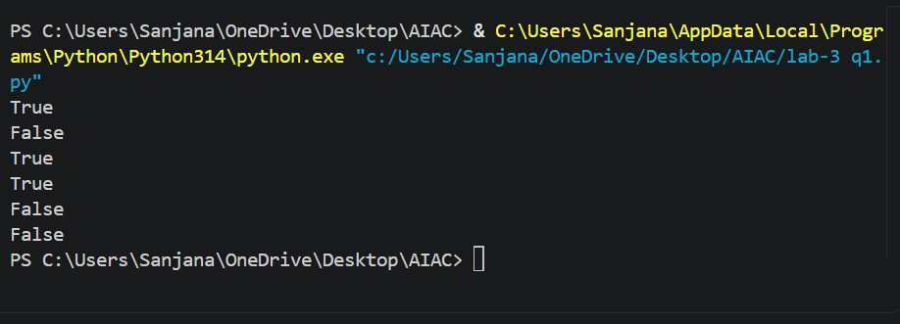

Question 2: One-Shot Prompting (Factorial Calculation)
Write a one-shot prompt by providing one input-output example and ask the AI to generate a Python function to compute the factorial of a given number.
Example:
Input: 5 → Output: 120
Task:
- Compare the generated code with a zero-shot solution.
- Examine improvements in clarity and correctness.
Prompt:
Write a Python function named factorial(n) to calculate the factorial of a given number.
Example:
Input: 5
Output: 120
Now generate the complete Python code for the factorial function. Handle zero, negative numbers, and invalid inputs appropriately.
Code:
def factorial(n):
if not isinstance(n, int):
return "Invalid Input"

if n < 0:
return "Factorial is not defined for negative numbers"

result = 1

for i in range(1, n + 1):
result = result * i

return result

# Test cases
print(factorial(5))
print(factorial(0))
print(factorial(3))
print(factorial(-2))
print(factorial("5"))
Output:
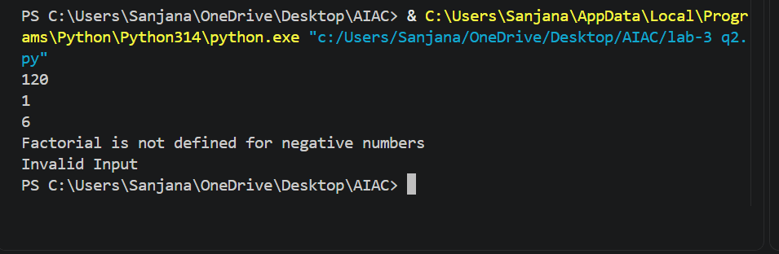

Question 3: Few-Shot Prompting (Armstrong Number Check)
Write a few-shot prompt by providing multiple input-output examples to guide the AI in generating a Python function to check whether a given number is an Armstrong number.
Examples:
- Input: 153 → Output: Armstrong Number
- Input: 370 → Output: Armstrong Number
- Input: 123 → Output: Not an Armstrong Number
Task:
- Analyze how multiple examples influence code structure and accuracy.
- Test the function with boundary values and invalid inputs.
Prompt: Write a Python function named is_armstrong(n) to check whether a given number is an Armstrong number.
Examples:
Input: 153 → Output: Armstrong Number
Input: 370 → Output: Armstrong Number
Input: 123 → Output: Not an Armstrong Number
Generate the complete Python code based on these examples. Handle boundary values such as 0, 1, and negative numbers, and handle invalid inputs such as strings. Also include test cases for multiple inputs.
Code:
def is_armstrong(n):
if not isinstance(n, int):
return "Invalid Input"

if n < 0:
return "Not an Armstrong Number"

digits = str(n)
power = len(digits)

total = 0
for digit in digits:
total += int(digit) ** power

if total == n:
return "Armstrong Number"
else:
return "Not an Armstrong Number"

# Test cases
print(is_armstrong(153))
print(is_armstrong(370))
print(is_armstrong(123))
print(is_armstrong(0))
print(is_armstrong(1))
print(is_armstrong(-153))
print(is_armstrong("153"))
Output:
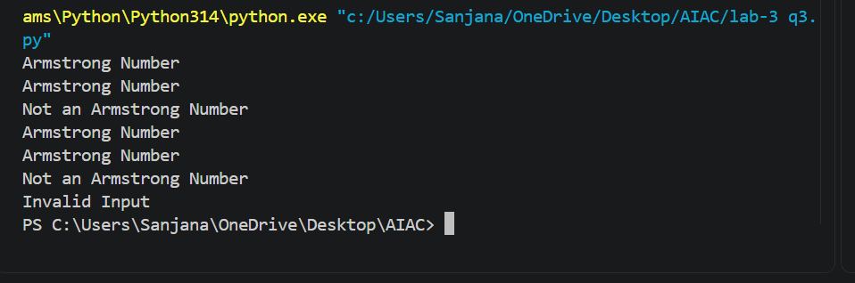

(Optional Extension)
Question 4: Context-Managed Prompting (Optimized Number Classification)
Design a context-managed prompt with clear instructions and constraints to generate an optimized Python program that classifies a number as prime, composite, or neither.
Task:
- Ensure proper input validation.
- Optimize the logic for efficiency.
- Compare the output with earlier prompting strategies.
Prompt:
Write a Python function named classify_number(n) that classifies a number as Prime, Composite, or Neither.
Requirements:
- Validate the input and reject invalid inputs such as strings, floats, and None.
- Numbers less than 2 should be classified as Neither.
- Check whether the number is prime or composite.
- Use an efficient method by checking factors only up to the square root of the number.
- Return "Prime", "Composite", or "Neither".
- Include test cases for boundary values and invalid inputs.
- Keep the code simple, clear, and efficient.
Code:
def classify_number(n):
# Input validation
if not isinstance(n, int):
return "Invalid Input"

# Numbers less than 2 are neither prime nor composite
if n < 2:
return "Neither"

# Check factors only up to square root of n
i = 2
while i * i <= n:
if n % i == 0:
return "Composite"
i += 1

return "Prime"

# Test cases
print(classify_number(2))
print(classify_number(7))
print(classify_number(10))
print(classify_number(0))
print(classify_number(-5))
print(classify_number("7"))
print(classify_number(3.5))
Output:
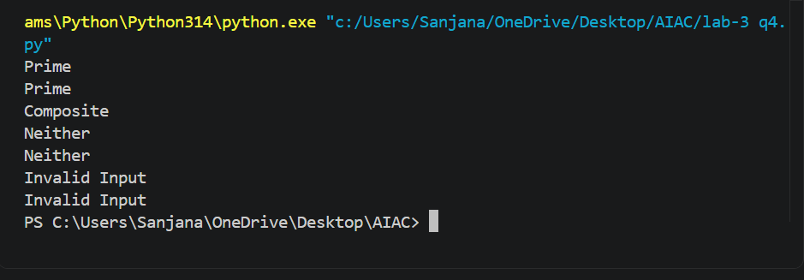

Question 5: Zero-Shot Prompting (Perfect Number Check)
Write a zero-shot prompt (without providing any examples) to generate a Python function that checks whether a given number is a perfect number.
Task:
- Record the AI-generated code.
- Test the program with multiple inputs.
- Identify any missing conditions or inefficiencies in the logic.
Prompt:
Write a Python function named is_perfect_number(n) to check whether a given number is a perfect number.
A perfect number is a positive integer that is equal to the sum of its proper divisors, excluding the number itself.
Return True if the number is a perfect number and False otherwise.
Handle invalid inputs, zero, and negative numbers appropriately. Generate the complete Python code and include test cases with multiple inputs. Do not provide any examples in the prompt.
Code:
def is_perfect_number(n):
# Input validation
if not isinstance(n, int):
return False

# Perfect numbers must be positive
if n <= 0:
return False

divisor_sum = 0

# Find proper divisors
for i in range(1, n):
if n % i == 0:
divisor_sum += i

return divisor_sum == n

# Test cases
print(is_perfect_number(6))
print(is_perfect_number(28))
print(is_perfect_number(12))
print(is_perfect_number(1))
print(is_perfect_number(0))
print(is_perfect_number(-6))
print(is_perfect_number("6"))
Output:
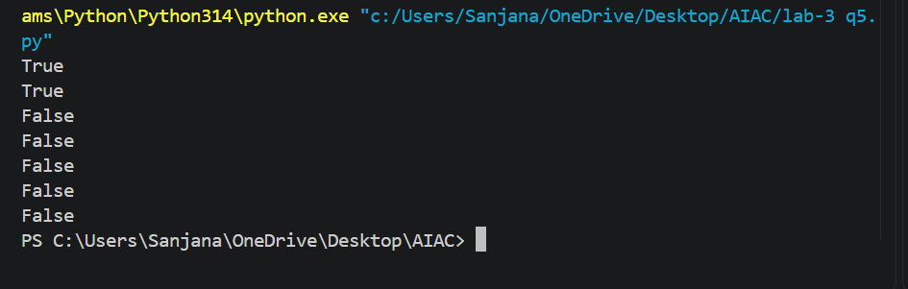

Question 6: Few-Shot Prompting (Even or Odd Classification with Validation)
Write a few-shot prompt by providing multiple input-output examples to guide the AI in generating a Python program that determines whether a given number is even or odd, including proper input validation.
Examples:
- Input: 8 → Output: Even
- Input: 15 → Output: Odd
- Input: 0 → Output: Even
Task:
- Analyze how examples improve input handling and output clarity.
Test the program with negative numbers and non-integer inputs.
Prompt:
Write a Python function named check_even_odd(n) to determine whether a given number is Even or Odd.
Examples:
Input: 8 → Output: Even
Input: 15 → Output: Odd
Input: 0 → Output: Even
Generate the complete Python code based on these examples. Validate the input and handle negative numbers and non-integer inputs such as strings, floats, and None. Return "Even", "Odd", or "Invalid Input" as appropriate. Also include test cases for multiple inputs.
Code:
def check_even_odd(n):
# Input validation
if not isinstance(n, int):
return "Invalid Input"

# Check even or odd
if n % 2 == 0:
return "Even"
else:
return "Odd"

# Test cases
print(check_even_odd(8))
print(check_even_odd(15))
print(check_even_odd(0))
print(check_even_odd(-4))
print(check_even_odd(-7))
print(check_even_odd("8"))
print(check_even_odd(5.5))
Output:
